Big Mountain Capstone Report

Big Mountain Resort has the ability to substantially increase its revenue in the coming year. Recently, we conducted a thorough analysis of the national ski resort industry and have gained a clearer understanding of the driving forces behind market support for ticket price. Based on this understanding we recommend the following three actions from Big Mountain’s executive team: raise the current ticket price to $95, add the 150ft run to your resort without additional snow making covering, close the least used run permanently.

Based on our model, the market currently supports Big Mountain increasing its ticket price to $95 without any changes required to its facilities. The following figure shows where Big Mountain’s current ticket price stands in relation to the general market: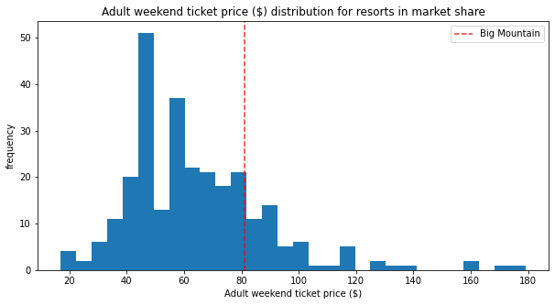

Big Mountain currently sits near the upper middle of the distribution but should sit closer to the top based on its available facilities. Such a price increase will generate an additional $24.5 million dollars in revenue if implemented.

Furthermore, our model suggests that Big Mountain should execute scenario two on its shortlist. By adding a run that increases the resort’s vertical drop by 150ft, the market will sustain a $1.99 increase in ticket price that will generate an additional $3.5 million in revenue. The following figure shows the relative importance of facilities on ticket price: 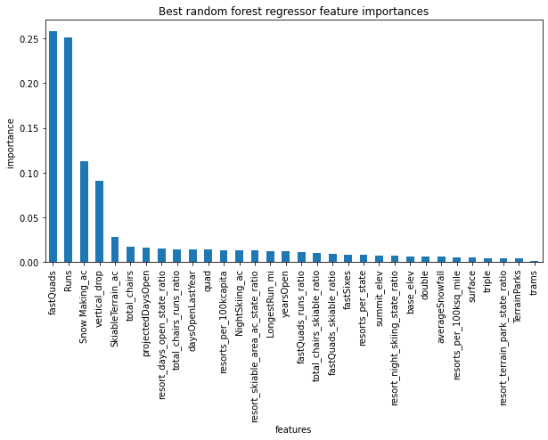

Because of Big Mountain’s dominance in the other categories, increasing our vertical drop is the most effective way to sustain a ticket price increase. In addition, our model found that because our snowmaking acreage is already so high, an extra 2 miles will not impact expected ticket price. By executing scenario two, Big Mountain can manage its costs while maximally impacting its revenue in a positive direction.

Finally,